**Scientific report generator**

Main objective of this system is to simplify report generation for employees of Ivan Franko National University of Lviv. System provides easy way of adding information about scientific work during report period.

**Roles:** teacher, head of department, administrator.

**Teacher:** registers an account providing his personal information. Also he can add data about scientific work, generate individual reports, create and edit publications and mark scientific work themes, he worked on.

**Head of department:** edits data of his department’s users, i.e. approving them, sets position and modifies their information. Head of department can register and update themes for scientific work, generate and edit department reports.

**Administrator:** can approve users, can edit their roles and other information of his faculty’s workers, can generate and modify faculty reports.

**Subsystems**

**User Management**

|  |  |  |  |
| --- | --- | --- | --- |
| **#** | **Role** | **Use Case** | **Description** |
| 1 | Administrator | Edit user | Edits information of his department’s users. |
| 2 | Approve registration | Approves new registered user of his department. |
| 3 | Set user role | Edits the position of his department’s users. |
| 4 | Teacher | Register | Registers a new account. |

**Report Management**

|  |  |  |  |
| --- | --- | --- | --- |
| **#** | **Role** | **Use Case** | **Description** |
| 1 | Administrator | Edit faculty report | Edits data of faculty report. |
| 2 | Generate faculty report | Generates report of his faculty. |
| 3 | Head of department | Generate department report | Head of department can create report of his department based on teachers’ reports. |
| 4 | Edit department report | Head of department can edit his department’s report. |
| 5 | Teacher | Fill report fields | Teacher can fill additional fields according to his personal report. |
| 6 | Edit teacher report | Teacher can edit information of his personal report. |
| 7 | Generate teacher report | Teacher can generate personal report of his work during the year. |

**Publication Management**

|  |  |  |  |
| --- | --- | --- | --- |
| **#** | **Role** | **Use Case** | **Description** |
| 1 | Head of department | Register  scientific work theme | Registers scientific work themes of his department. |
| 2 | Edit scientific  work theme | Edits registered scientific work themes. |
| 3 | Teacher | Create publication | Adds publications as single or co-author. |
| 4 | Edit publication | Edits created publications. |
| 5 | Mark themes he participated in. | Sets himself as co-author of scientific works. |

**Diagrams**

General use case diagram

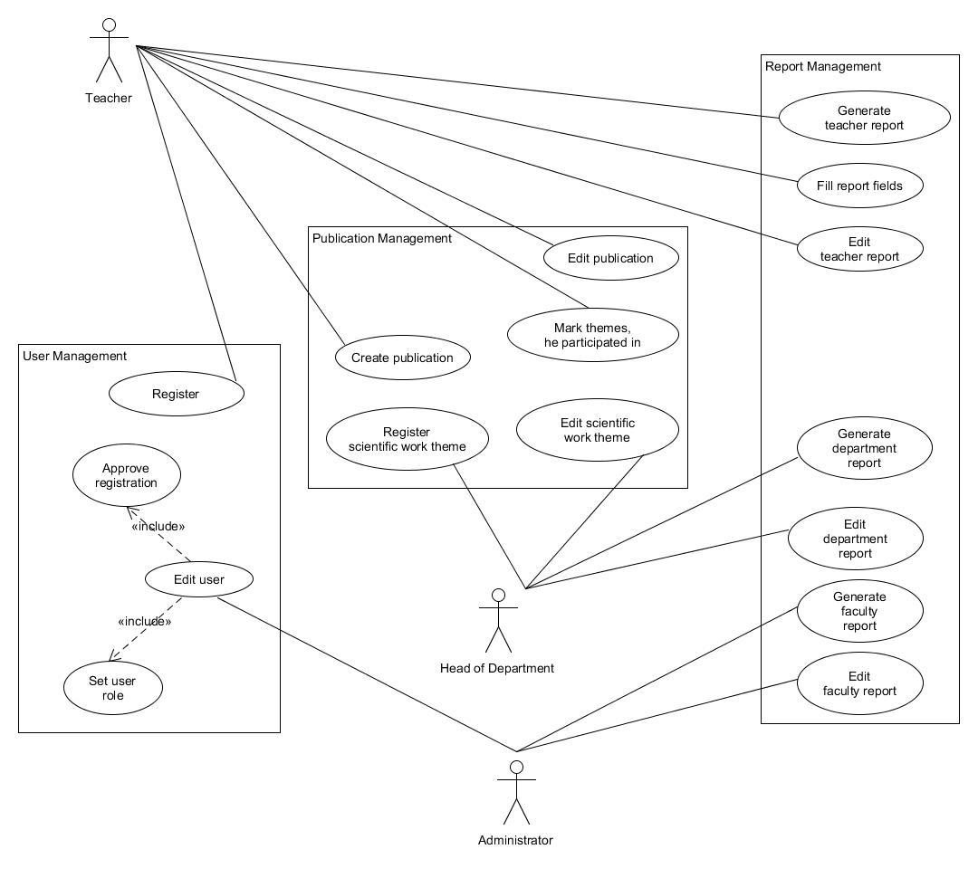

Use case for Administrator role

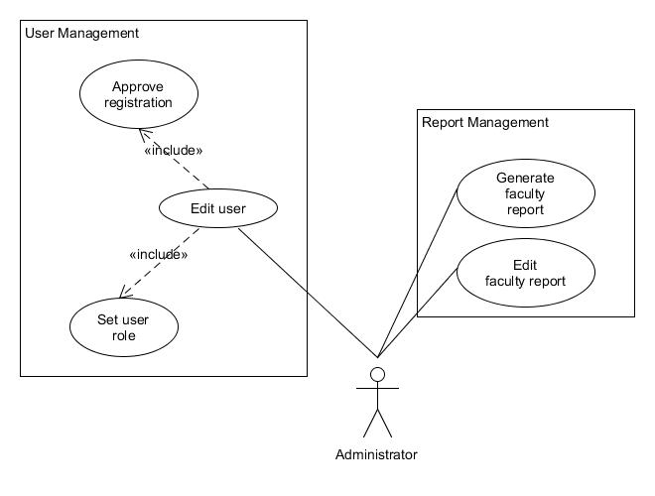

Use case for Head of Department role

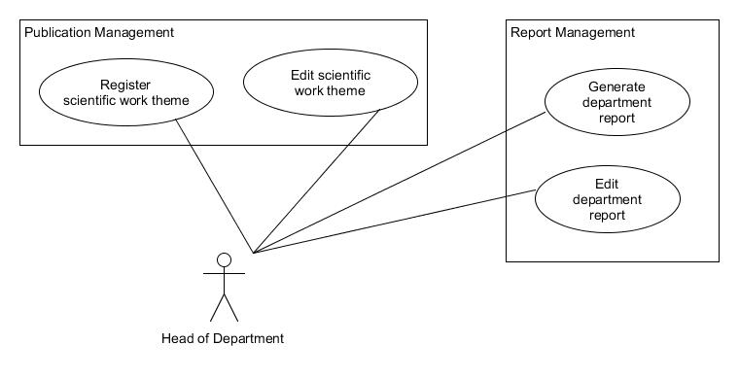

Use case for Teacher role

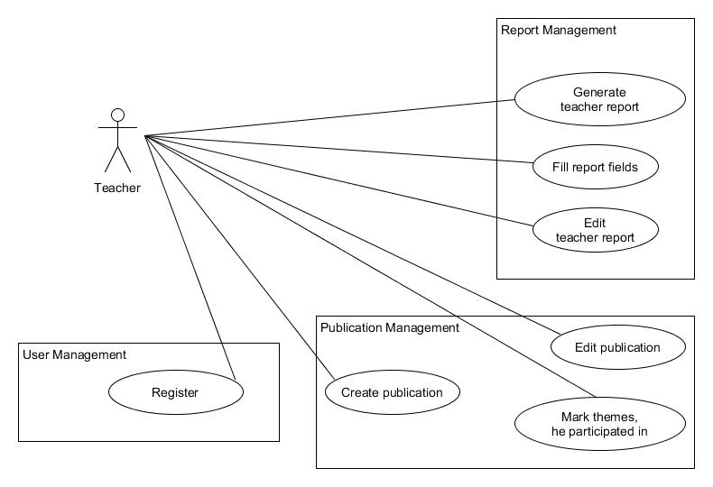

Sequence diagram

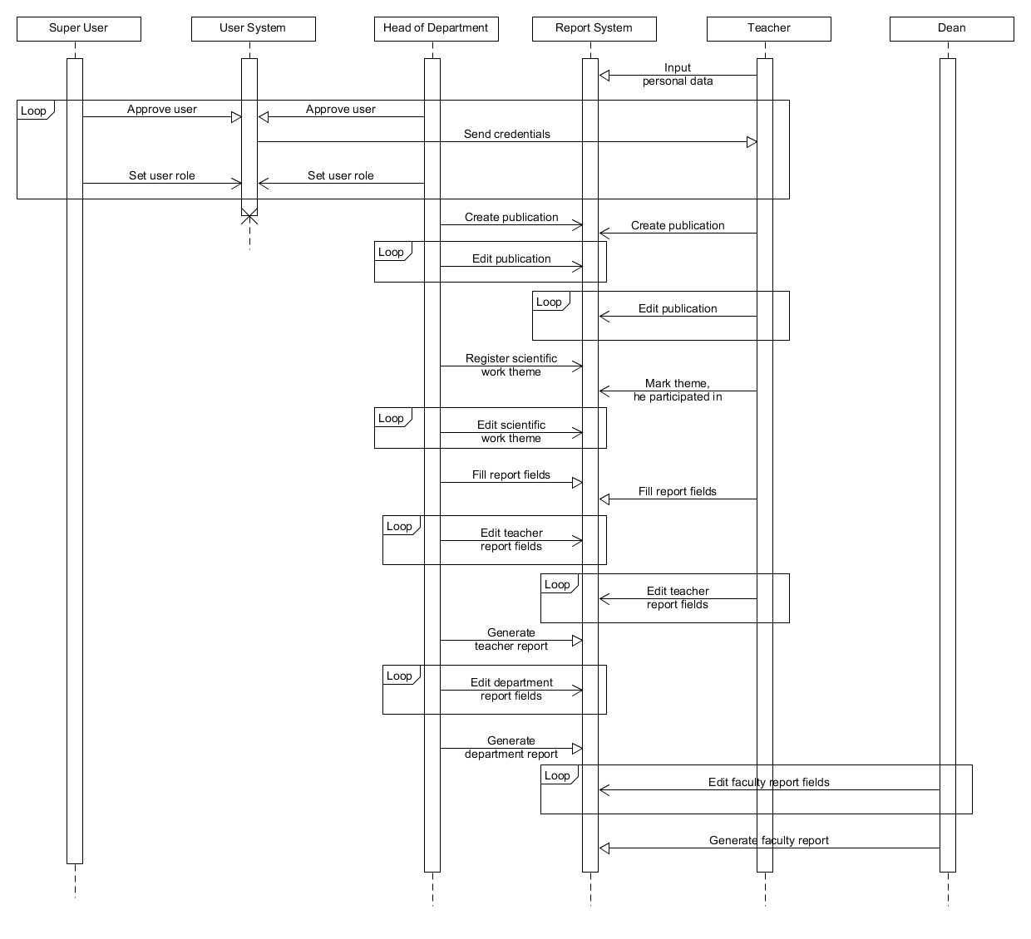

Class diagram

